2020
Yanti Lacsana and Nila Wardani
Circle Indonesia - Rumpun
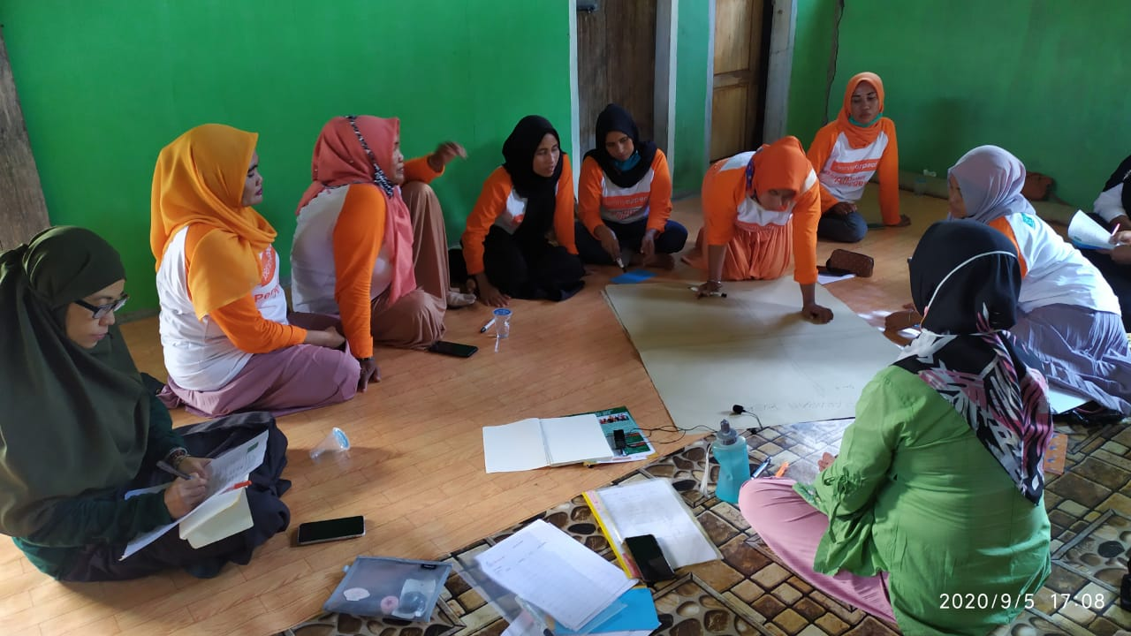
Final Evaluation of YAPPIKA-ActionAid Tsunami Emergency Response and Recovery Programme in Central Sulawesi Indonesia

FINAL EVALUATION
YAPPIKA-ACTIONAID TSUNAMI ERR PROGRAMME
IN CENTRAL SULAWESI PROVINCE
INDONESIA

Prepared by:
Yanti Lacsana, Circle Indonesia Co-op
Nila Wardani, Rumpun Foundation

Commissioned by:
YAPPIKA-ACTIONAID INDONESIA

October 2020

ACKNOWLEDGEMENTS

This evaluation was made possible with the support of and cooperation from the team at Yappika ActionAid office in Jakarta and Palu, Central Sulawesi. The team appreciates their willingness to ensure that the process went smoothly, allowing all related documents to be reviewed and examined to provide basis for analysis and lay foundations for the exploration and attainment of data and information from the field work. The team would like to thank Fransisca Fitri, YAA Executive Director, Hendrik Rosdinar – Programme Manager, Rochmad Munawir, and Riena Luciana, Stella and Indy at the Jakarta office; also, Wawan Probo, Hari T and Devy at YAA office in Palu who have provided tremendous help, not only as resource persons but also in organizing and facilitating meetings with partners and other stakeholders and travel arrangement to the field.
We also want to thank Abdul Haris and his staff from WALHI Sulteng, Nur Syafitri Salibani and her staff from Sikola Mombine, and Zulfiyah Mansur, as well as colleagues from Fatayat NU, for their time and cooperation in making sure this evaluation went well, providing data and information openly and ensure that we have access to the communities they have supported.
Our thanks also extend to the Head of BP3D Sigi, Sutopo; head of Disaster Preparedness, BPBD Palu, Mr. Gayus Pakan, and Head of Sub-division of Women Empowerment from DP3A Province, Mrs. Sukarti and her staff – who have kindly shared with us their concerns and government future plans in addressing various issues that have arisen post-disaster. We also express our appreciation for colleagues from various humanitarian agencies presence in Palu, such as Koalisi Sulteng Bergerak, CARE International Indonesia, JMK Oxfam, Mercy Corp who have shared with us their story and experiences in managing humanitarian responses in Central Sulawesi.
We also thank Sukmawati, Fathan and Marlina Farouk, the research assistants, who have collected all data and information in the field: with their help this evaluation could be undertaken as planned.
Last but not least, and most importantly, we are thankful for the women groups, village authorities, community elders and other community members in Beka, Buluri, Dampal, Duyu, Rano and Rogo, who have shared their amazing stories, reflection and dreams so that we could learn about the benefit of the programme as well as inputs for the future. They have shown us the wonderful learning on local resilience and strength, the spirit of survival and their undying vision for a better future.

October 2020
Evaluator team:
Yanti Lacsana, Circle Indonesia Co-op
Nila Wardani, RUMPUN Foundation

EXECUTIVE SUMMARY

YAPPIKA-ActionAid Indonesia launched the emergency response and recovery (ERR) programme in three districts of Central Sulawesi from October 2018 to September 2020. This response was implemented to address the impact of the earthquake and tsunami that struck the area, and caused destruction to the environment, resulting in more than 100 000 people losing their homes and the loss of more than 4 000 lives. The programme aimed at helping the most vulnerable groups affected by the disaster, namely women and children, to regain their footing and well-being and have access to protection mechanisms in the face of the dire situation the tsunami created. The project also involved women taking up leadership roles as focal points in their respective communities, to address the humanitarian crisis and facilitate the restarting of their livelihood activities to support their household and community economy.
The evaluation aims at providing inputs for the improvement of humanitarian actions by ActionAid and other humanitarian agencies. It also provides an analysis on adherence to accountability measures in humanitarian responses, and the assurance that women and other vulnerable groups affected by this disaster have been adequately supported by the programme.
The Core Humanitarian Standards (CHS) are used as a basic framework for the evaluation with reference to several other standards, such as ActionAid’s (AA) Accountability Framework and the Women-Led Community-Based Protection (WLCBP) concept. The evaluation used a combination of participatory approaches for data collection and analysis which included, amongst others, appreciative enquiries, participatory reflection and review processes, Focus Group Discussions (FGD), Key Informant Interviews and various tools for gender analysis and rural appraisal such as village mapping, Venn diagram, Harvard Gender Analysis Matrix, etc.
The analysis shows that overall, the programme has achieved almost all its objectives as outlined in the programme design and theory of change. The programme also demonstrates compliance with almost all CHS criteria but needs more work in the areas of coordination and collaboration among the partner organizations, accountability to affected populations and achieving a full participation of the community in decision-making processes.
One of the most notable achievements is the emergence of many women leaders among the communities. The programme, facilitated by the partner organisations, was able to successfully build the capacity of local women to become more confident and self-reliant, by providing spaces where they can express their concerns and opinions freely. Capacity building and strengthening the local capacity and community resilience are clearly the areas where this programme excels; cost efficiency and capacity to deliver results with the optimal use of resources is also another winning point for the programme. While the financial benefits were comparatively insignificant, for example the income from livelihood activities, the programme has clearly invested in the future by using the resources to develop local institutions, knowledge transfer and experiences and hone the skills of local partners and communities, particularly women, to address humanitarian crises and creating opportunities for women’s leadership in this area.
The programme findings that could be identified as lessons learned are as follows:
- The requirement to follow the CHS and AA humanitarian standards such as the Accountability Framework, AA’s Humanitarian Signature and WLCBP should be accompanied with proper guidance on how to understand and put them into operation. Partners did follow YAA’s guidance but were yet to understand fully how it is interpreted in the design and implementation;
- The initial assessment was sufficient to make informed decisions for the programme design, particularly in the first phase. In the second phase, however, a more in-depth needs assessment should be carried out to better address the needs of the community, instead of responding to a “wish list” such as in implementing livelihood activities where only a few of the beneficiaries could participate meaningfully;
- Working with women focused organizations is a strategic choice of partnership. It is important, however, to provide clear guidance, regular monitoring and mentoring on how to measure their performance to ensure that it is in line with YAA’s agenda on women-led protection programmes humanitarian contexts;
- The scale of the programme and type of intervention was quite challenging for implementing partners. Proper support to improve their capacity in planning, operations and financial management should be an integral part of the capacity building intervention from YAA;
- Different focus, agenda and characteristics of partners affect the level of coordination and cooperation between implementing partners. While each achieved the targeted outputs, there was no connection or complementary agenda amongst them. Inter-partner cross learning and support should be encouraged and promoted;
- Livelihood activities, albeit small in scale and limited to the production of certain commodities only, are a good entry point at the community level and have a lot of potential to be scaled up for sustainability;
- Advocacy work should be inherent to the activities on the ground, as many initiatives could be promoted with sufficient support from relevant government agencies, be it in the form of legalizing land titles by village authorities, or providing links to external resources for scaling up production and access to markets, or improving product quality and business management capacity;
- While the programme has encouraged partners to facilitate community-based disaster risk mapping, there is little understanding on how to assess the environmental impact of disasters or whether a mitigation plan is in place; and
- It is unfortunate that the programme, despite YAA’s expertise and experience in advocacy work, has not yet addressed the pertinent issues relevant to disaster risk reduction and humanitarian action in the region; partners only launched sporadic advocacy work without significant results related to the rights of survivors. Interestingly, at the village level, several women, who engaged in the programme have successfully advocated for these issues and influenced government decisions – such as in obtaining a living allowance as well as a stimulant fund for housing. This needs to be documented and promoted for possible replication in other areas.

Recommendations for the improvement of the humanitarian actions:

- Set up a proper management structure for the ERR team: A defined management structure through partnerships or direct implementation would increase its effectiveness in managing humanitarian actions;
- Have YAA lead on coordination: For the coordination to be effective and strategic, YAA, based on its strengths and extensive experience, should take a leadership role in coordination from an early stage;
- Focus on organizational strengths and comparative advantages to increase visibility and significant impact: The promotion of WLCBP and AA’s Accountability Framework in humanitarian action would be more beneficial in the long run rather than investing in physical construction where AA probably has limited experience and expertise;
- Invest more in capacity building: Ensure that sufficient resources are being invested to map the available local institutions and human resources, with a clear mechanism and faculty for capacity building. This is particularly relevant to areas that are key to YAA/AAI such as in WLCBP, various humanitarian standards and frameworks, organizational management, including the capacity to evaluate environmental impacts. This applies to both partners and internal organizations;
- Use screening tools to select partners: No matter how small the window of opportunity is to conduct a stakeholder analysis, it is imperative to choose partners that are strategic to implementation based on a proper assessment. The use of YAA tools such as OCPAT would be useful to assess the capacity of local civil society organizations to engage in humanitarian action;

- Set exit and sustainability strategies: Despite the short period of engagement, it is necessary to integrate an exit strategy into each programme’s design so as to ensure that there is a proper handover in place, and to sustainability map out interventions that have potential to develop post-ERR;
- Proactively seek engagement with the government early on: It is important to engage early with the government, not only to increase visibility, but also to pave the way for future work should there be themes that need to be scaled up, promoted or supported by the government, and also to ensure a smooth handover of the programme by the end of the intervention. Such a relationship is also useful in case the programme and/or partners have an advocacy agenda related to survivors’ rights and empowerment in the aftermath of a disaster;
- Document and study ERR programme experience: It is important to continue learning from experiences, to continually improve humanitarian action considering that disasters could happen anywhere in different forms, scales, and circumstances. To enrich YAA’s repository, documentation and inventory of best practices, lessons learned, and successful models of women-led disaster management programmes where ActionAid has engaged would be valuable input for the organization in developing effective engagement strategies;
- Ensure all internal systems for programme support and management are well understood by all parties involved: It is important that all staff and partners involved understand what to expect from the project’s performance. The MOU should clearly spell out the rights and obligations of the partnership, including accountability measures, M&E system, grievance mechanisms, transparency and all the dos and don’ts to avoid mishaps or misinterpretation along the way.
- Set up a support system available to staff involved in the humanitarian response: Emergency situations are extremely stressful and hard on staff. It is important that proper services are also available to address staff well-being and avoid occupational hazards. Psychosocial services, R&R and other incentives to create a work-life balance should be integrated in SOPs and HR policies;
- Build local CSOs organizational strength for follow up advocacy programmes: YAA in Indonesia is recognized as an advocate to promote inclusive education and often leads in advocating socio-economic and citizens’ rights, both at the sub-national and particularly at the national levels. It would be strategic to use this experience and expertise to support local advocacy groups in their identifying issues that need to be tackled post-disaster. Further discussion with local CSOs as well as coordination with the local government could be the next step that YAA takes in the future.

GLOSSARY

AAUK: ActionAid UK
ACT: Aksi Cepat Tanggap (Rapid Response Action) – independent national humanitarian organization formerly set up by Social Justice Party
AI: Appreciative Inquiry
ALNAP: Active Learning Network for Accountability and Performance
APPKD: Anggaran Pembangungan dan Pembelanjaan Kelurahan/Desa (Village/Sub-subdistrict Development and Expenditure Budget)
BP3D: Badan Perencanaan dan Pengawasan Pembangunan Daerah (Regional Office of Development Planning and Monitoring)
BPBD: Badan Penanggulangan Bencana Daerah (Regional Disaster Management Agency)
BPBP: Badan Penanggulangan Bencana Nasional (National Disaster Management Agency)
BPN: Badan Pertanahan Nasional (National Land Agency)
BPD: Badan Permusyawarahan Desa (Village Deliberative Body)
BUMDES: Badan Usaha Milik Desa (Village-owned Enterprise)
CHS: Core Humanitarian Standards
CO: Community Organizer
DEC: Disaster Emergency Committee
DP3A: Dinas Pemberdayaan Perempuan dan Perlindungan Anak (Women Empowerment and Child Protection Office)
Dinsos: Dinas Sosial (Social Affairs Office)
Disdagtri: Dinas Perindustrian dan Perdagangan (Industry and Commerce Office)
Distan: Dinas Pertanian (Agriculture Office)
ERR: Emergency Response and Recovery
FGD: Focus Group Discussion
FNU: Fatayat Nahdlatul Ulama (Young Women’s Islamic Organization)
GBV: Gender-based Violence
KBS: Koalisi Sulteng Bergerak (Central Sulawesi Action Coalition)
JMK Oxfam: Jaringan Mitra Kemanusiaan Oxfam (Humanitarian Knowledge Hub – 16 NGOs)
Kemenaker: Kementerian Tenaga Kerja (Ministry of Manpower)
Kemendag: Kementerian Agama (Ministry of Religion)
KII: Key Informant Interview
MDMC: Muhammadiyah Disaster Management Centre
Pasigala: acronym for the Palu, Sigi and Donggala districts affected by the earthquake and tsunami that occurred on 28 September 2018
Perdes: Peraturan Desa (Village Ordinance)
PO: Programme/Project Officer
PRA: Participatory Rural Appraisal
PRB: Peta Resiko Bencana (Disaster Risk Map)
PSS: Psychosocial support
PUPR: Pekerjaan Umum dan Perumahan Rakyat (Public Works and Public Housing)
RTRW: Rencana Tata Ruang Wilayah (Spatial Planning)
SM: Sikola Mombine (Mombine School for the education of women)
SP: Solidaritas Perempuan (Women’s Solidarity)
Toga: Tokoh Agama (Religious Leader)
Todat: Tokoh Adat (Customary Leader)
Tomas: Tokoh Masyarakat (Community Leader)
WALHI Sulteng: Wahana Lingkungan Hidup Sulawesi Tengah (NGO Environment Coalition)

WASH: Water Sanitation and Hygiene
WFS: Women Friendly Spaces
WLCBP: Women-Led Community-Based Protection
YAA Indonesia: YAPPIKA-ActionAid Indonesia

